K.BHANU TEJA

192111320

OOAD LAB EXPERIMENTS **DAY-4**

**1.** **Develop a system using UML for Online Voting System. Registration of the new citizen and update can be done in the system. The process of initiating the polling. The voting was done from the citizen’s end and the result publishing should be maintained by the admin.**

**AIM:-**

To develop a system using UML for Online Voting System.

UML DESIGNS:-

1.STATECHART DIAGRAM:

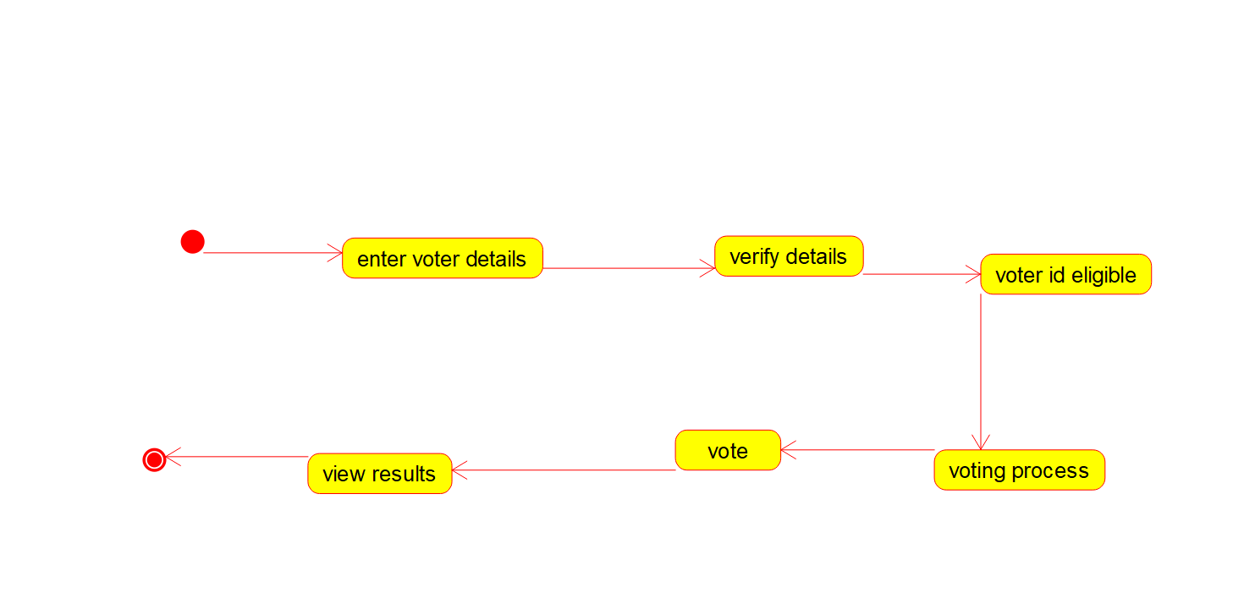

2.COLLABORATION DIAGRAM:

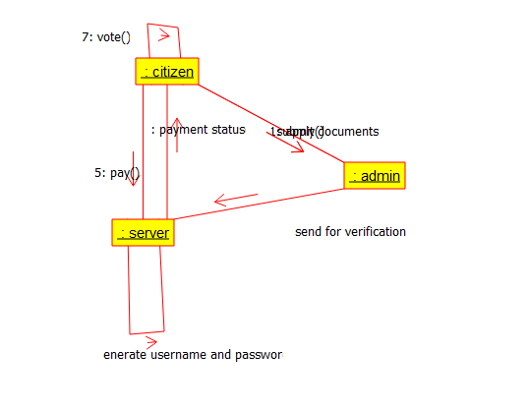

3.SEQUENCE DIAGRAM:

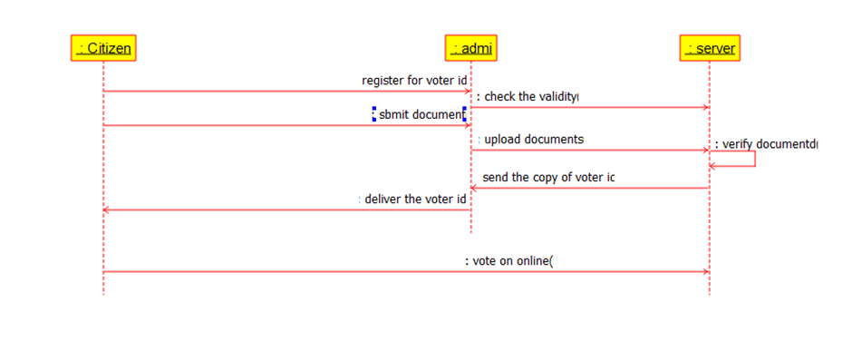

Component diagram

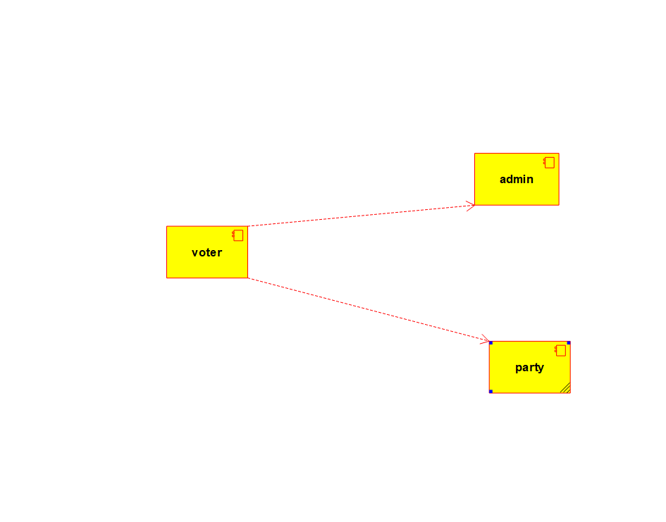

**Deployment diagram**

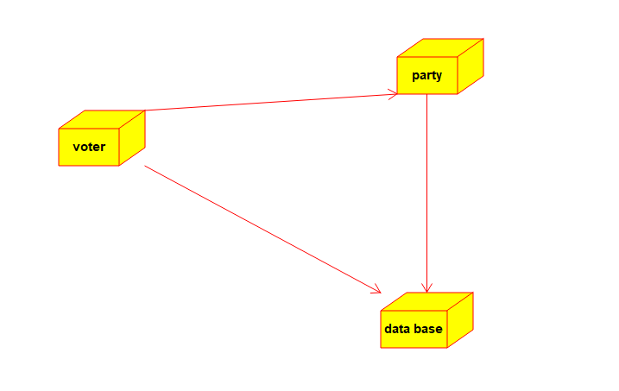

**Object diagram**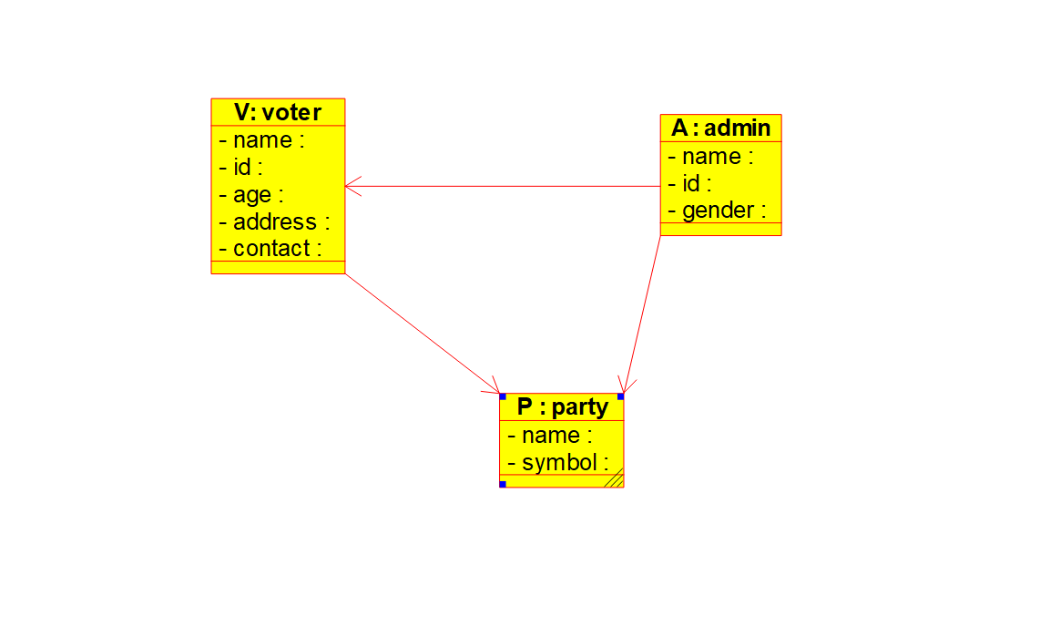

**Class diagram**

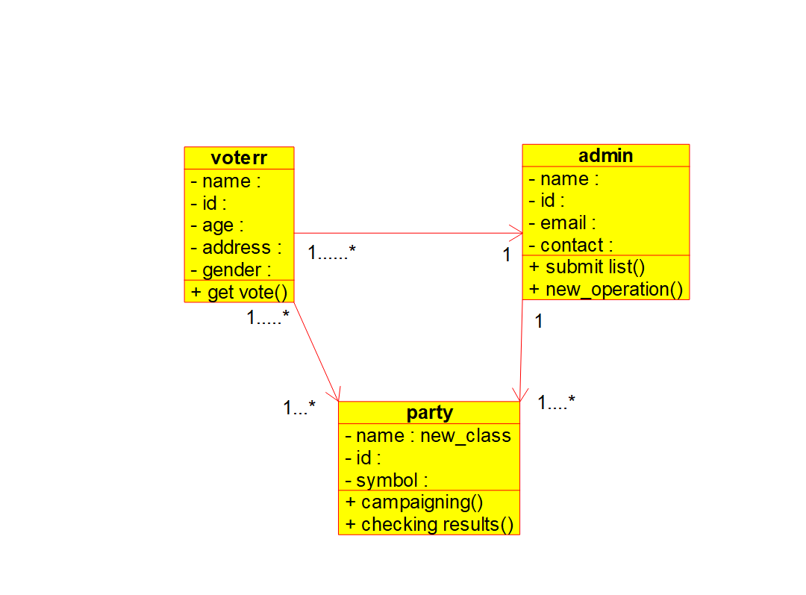

**Activity diagram**

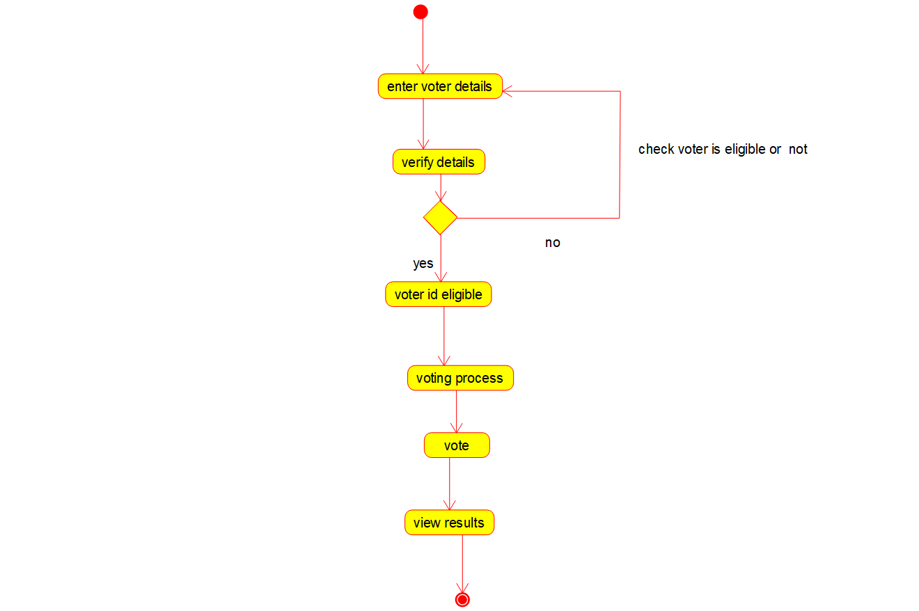

**Use case diagram**

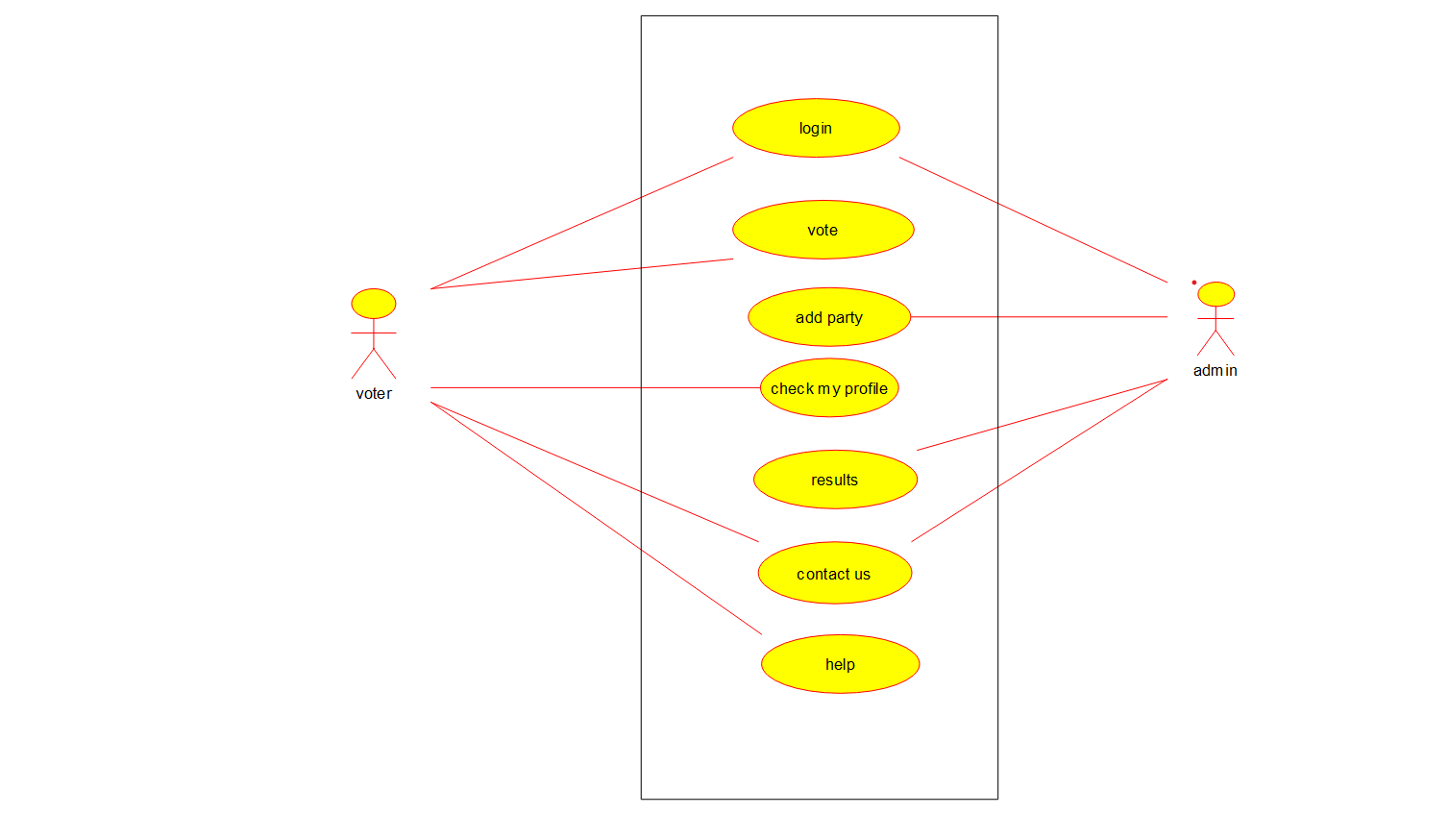

**2. Develop a system using UML for Supermarket Management System. The system should maintain the stock detail, employee detail, and customer details. The system should intimate the product with low stock and nearing the expiry date. The loyalty feature of the customers should be maintained. The offers to the customers should be based on their loyalty features.**

**AIM:-**

To develop a system using UML for Supermarket Management System.

UML DESIGNS:-

1.USE CASE:

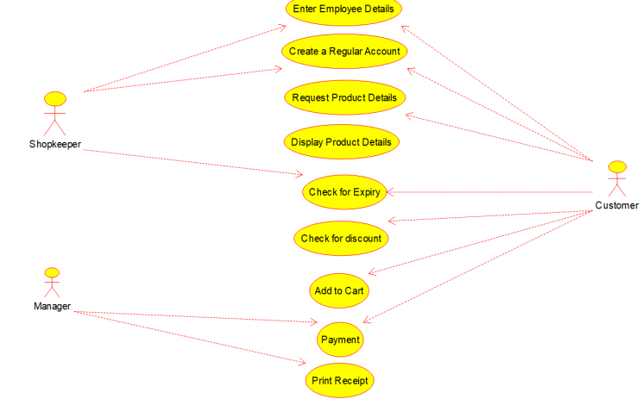

2.CLASS DIAGRAM:

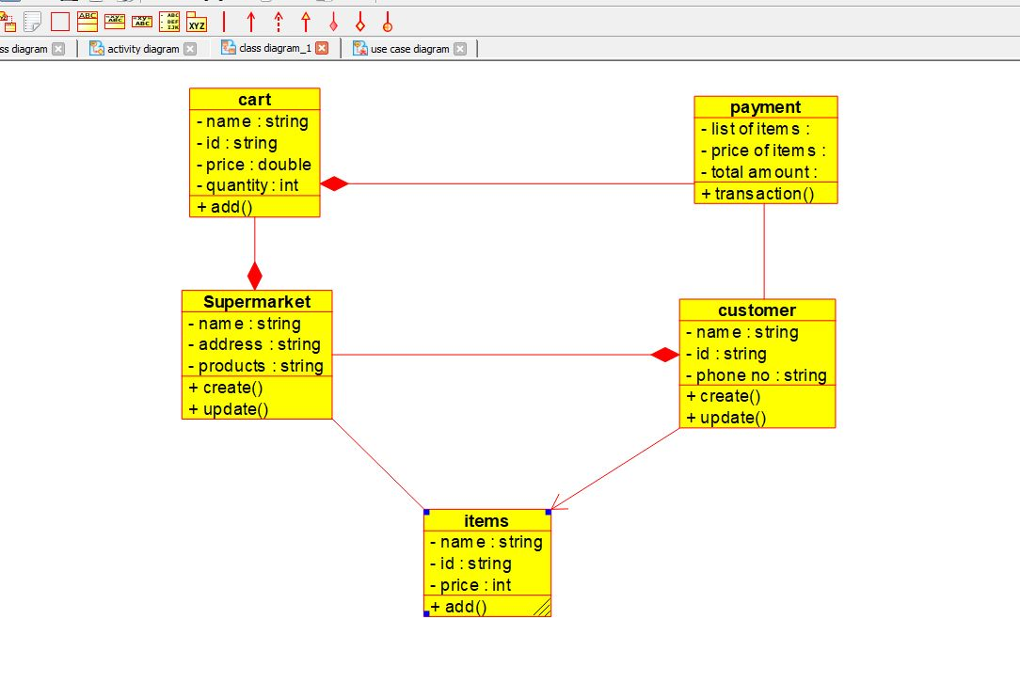

3.ACTIVITY DIAGRAM:

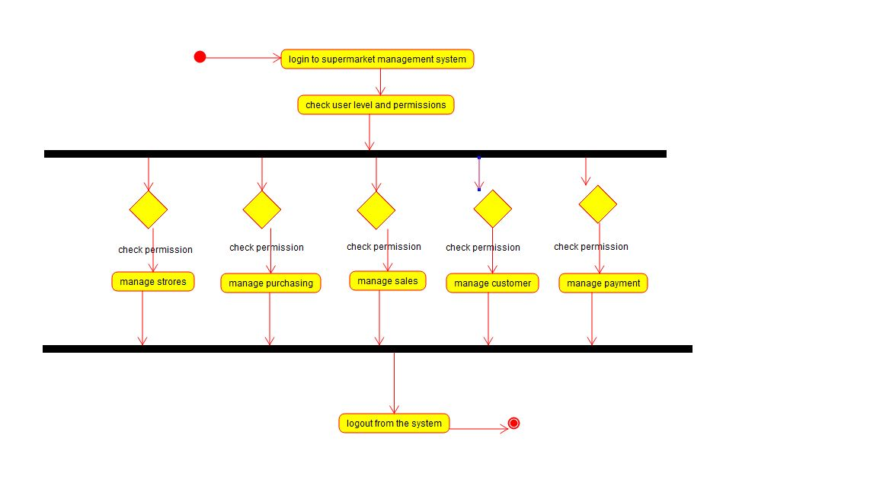

**Sequence diagram**

